Introduction
Unlike ground-based or airborne approaches, space-based measurements provide broad regional or global coverage with great temporal precision, making them valuable in a number of applications [1]. As climate change becomes more severe, advanced as well as responsive technologies are required. Emerging CubeSat-based hyperspectral optical imaging payloads are meeting this demand, revolutionizing how we perceive climate and environmental change from orbit. These platforms are low-cost, compact, and versatile, making them suitable for remote sensing applications such as weather forecasting, water resource management, pollution tracking, agricultural monitoring, and disaster response, including wildfires, floods, and hurricanes [2].
In 1999, Professor Jordi Puig-Suari of Cal Poly and Bob Twiggs of the University of Stanford [1] devised a pioneering CubeSat design that offered low-cost access to space as a piggyback secondary payload on a large vehicle [3] [4]. Further, they have developed a standard that states that a 1-unit (1U) CubeSat shall measure 10 × 10 × 10 𝑐𝑚3 and weigh no more than 1.33kg, with typical power consumption on the order of a few watts, while available data rates do not exceed 1 Mbps [1]. This platform has also been designed with a wide range of sensor payload systems such as GNSS receivers, spectrometers, and advanced imaging (e.g., a CCD camera) capabilities, allowing them to capture high resolution images of the Earth’s surface as well as investigate other celestial bodies [4]
Figure 1 depicts concept of operation (ConOps) of a 3UCubeSat equipped Hyperspectral optical imager payload along with other subsystem conceptual mission operations to acquire images of the Earth. The prospects of CubeSat platform provide new avenues for commercial applications, including earth observation, communication, and scientific research. These applications have been reinforced by improvements in several technological domains, including advanced electronics and optics, new materials and optomechanical manufacturing techniques, signal processing, computer technology, communication, navigation, and pattern recognition and image processing algorithms [4] [5].
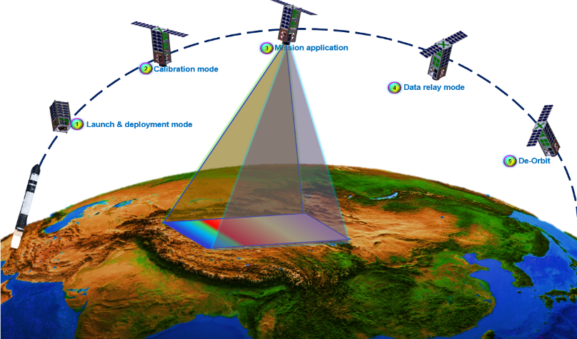

Figure 1: Schematic of ConOps of 3U CubeSat equipped hyperspectral optical imaging payload

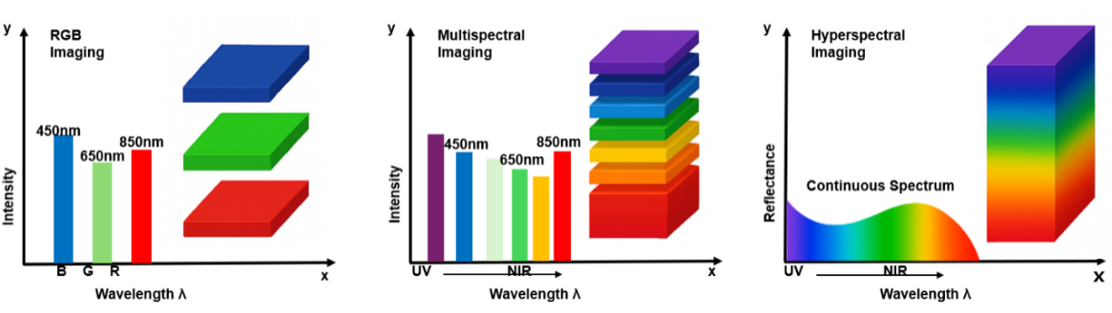
Since the inception and early development of smallsat including CubeSat, many missions, programs, technological demonstrations, and experimental investigations on scalability and performance improvement have been done vigorously in various parts of the world. The majority of non-constellation CubeSat research and development appears to have been carried out by the United States (43.1%), followed by Europe (22.3%), Asia (16.5%), and Russia (7.1%) [6].
Figure 2: Simplified overview and comparison of optical imagers including RGB, multispectral, and hyperspectral capabilities.

Moreover, several studies have contributed to the understanding and advancement of optical payload aboard small satellites (e.g., CubeSats, nanosatellites, and micro satellites) with hyperspectral, multispectral, and panchromatic capabilities. Figure 2 demonstrates comparison of optical imagers between RGB (left side), multispectral (center), and hyperspectral (right-side) in terms of spectral range and wavelength. Hyperspectral imagers acquire imagery from hundreds of narrow, contiguous spectral bands, providing detailed spectral information, enabling material identification and quantitative retrievals in Earth observation, planetary science, and environmental monitoring.
Mouroulis et al. [7] conducted trade studies on first-order requirements and technological advancements in multi-and hyperspectral imaging systems to address current scientific needs and enable new applications. Further, Qian [8] presented an overview of spaceborne hyperspectral imager technologies along with mission objectives, emphasizing instrument performance metrics and technical specifications. Till date, several hyperspectral imagers that are compatible with the CubeSat platform have been developed and used in several missions and table 1 depicts some of those payloads. The adoption of hyperspectral imaging using CubeSats cuts across both academic and commercial applications. But due to the volume constraints of CubeSats, several design configurations have been explored with the aim of potentially rendering a more compact, high performance optical payload
Liu et al. [9] designed a freeform pusbroom hyperspectral imager combining a freeform reflective triplet imager and a freeform reflective triplet spectrometer. The design operated at a #F/2 with a 15 degrees cross-track FOV and a 30mm entrance pupil diameter covering a wide spectral range of 400-1700nm (visible to short-wave infrared) while maintaining a high spectral sampling rate. Their nominal design achieves a 5.5𝜇𝑚 average RMS spot size and distortion less than 25% of a pixel, with misalignment tolerances of 10𝜇𝑚, tilt tolerances of 0.35 arcmin, and figure error tolerances of 10 mm on the first 25 Fringe Zernike polynomials. But most importantly, the adoption of freeform surfaces for the optical designed yielded a compact hyperspectral imager with a 91 x 161 x 116mm3 dimension which can be fully contained in a 3U format.
Lee et al. [10] presented a compact imaging spectrometer for use in the STSAT3 microsatellite. The imager was catadioptric telescope with an Offner-type configuration and a customized prism. To further achieve compactness, a curved grating element was used which made it possible to reduce the number of optical elements thereby shortening the optical path. The imager was designed to capture images of the Earth’s surface and atmosphere with a Ground Sampling Distance of 30m across the spectral range of 400 – 1050nm while being compact.
Graham et al. [11] also developed an experimental prototype of a compact, robust, all-aluminum hyperspectral imager based on a freeform three-concentric-mirror (Offner) optical configuration and a freeform diffraction grating operating at F/2.8 with a spectral resolution of 8 nm and employing an InGaAs sensor covering the 0.7–1.7 𝜇m spectral range. This configuration enables broad spectral coverage, accurate moisture assessment, and achieves up to a 30% reduction in RMS wavefront error across both spatial and spectral domains.

Jin et al. [12] presented the optical design of a Ritchey Chrétien-type reflecting telescope for CubeSat missions, utilizing off-axis segmentation techniques with primary rectangular mirror dimensions of 8×8 cm and secondary mirror size of 2.4 × 4.1 cm. The optical payload can capture a 4 ×2.3km region of earth’s surface from a 700 km altitude using a 120×800 CMOS color imaging sensor with an MTF of approximately 0.3 and 3.2 × 2.8mm image area. Their findings reveal a feasible approach for enhancing spatial resolution in CubeSat-based optical telescopes for space exploration. Mouroulis et al. [13] demonstrated a hyperspectral optical imaging payload designed for a 6U CubeSat, with the optomechanical bench compactly integrated within a 4U (20 × 20 cm) frame. The system operates at F/1.8 with a 100 mm focal length, a 10◦ FOV, and 600 cross track pixels, covering a spectral range of 350–1700 nm with 5.7 nm sampling. The spectrometer performed similarly to conventional airborne sensors while significantly reducing size and extending spectral coverage up to 1700 nm.
Esposito and Marchi [14] reported the first on-board demonstration of a small hyperspectral imager with a three-mirror anastigmat (TMA) telescope configuration which enables it with fit into a 1.5U CubeSat form factor. The optical payload had an on-board processing unit to analyze the quality of image data acquired by the HIS payload. This HIS can acquire high-quality imagery data with a radiometric accuracy of less than 5% and sub-pixel geometric performance of 0.48 pixels across track and 0.51 pixels along track.
It is also important to note that advances in space mission design, such as hyperspectral imaging constellations [15] and spacecraft miniaturization, have significantly improved hyperspectral optical payloads in the visible and near-infrared (VNIR) range by incorporating AI-powered analytics to provide actionable Earth observation insights. For example, Esposito et al. [16] presented the first CubeSat mission with on-board AI employing combined hyperspectral and thermal imaging, whilst Aoyanagi [17] developed a 35-g compact hyperspectral camera with a linear variable filter and image sensor.
Many CubeSat hyperspectral imagers adopt off-axis optical configurations in either the fore optics or the spectrometer to achieve high spectral fidelity within limited volume. While effective, such architectures typically increase alignment complexity and fabrication cost due to the use of freeform or concave–convex reflective gratings, which can hinder manufacturability and scalability [18]. Consequently, transmissive spectrometer architectures based on prism–grating (PG) or prism–grating–prism combinations have attracted increasing attention [18], [19] [20], owing to their ability to balance spectral dispersion while mitigating smile distortion and chromatic non-uniformity.
In contrast to existing approaches, this work presents a compact hyperspectral imaging payload in the visible spectral range (450 – 650 nm) based on an on-axis prism–grating spectrometer integrated with a modified classical Cassegrain telescope (primary conic constant K = −1, secondary K = 0) within a 1.5U CubeSat envelope. To accommodate the spectrometer under strict length constraints, the system departs from the conventional Cassegrain configuration by repositioning the image plane between the primary and secondary mirrors. This enables internal placement of the collimator and spectrometer, substantially reducing the effective optical path length while preserving rotational symmetry, alignment robustness, and manufacturability.
This study is structured as follows: Section 2 discusses the methodology for the HSI optical payload system design approach and requirement definitions, as well as sensor selection and optomechanical system analysis, which covers both optical and structural design analysis. Section 3 covers CubeSat hyperspectral optical imaging payload performance analysis in terms of image quality and aberration, spectra/spatial resolution, SNR/sensitivity analysis, and optical tolerancing. Section 4 summarizes this work

Hyperspectral Imager Specifications
2.1 System Requirements
The hyperspectral imaging payload requirements were defined to align with a typical CubeSat Earth-observation imaging payload and localized for measuring visible-band reflectance linked to plant pigments. Table xxx shows the complete system requirements and their description. It is important to note that the payload is constrained to the CubeSat form factor elements (power, ≤8–10 W during imaging and volume, ≤1.5U) within a 3U bus. So, all other components must fit tight within the residual volume while meeting the below spectral and radiometric performance targets
Requirements | Description
Mission objectives | Vegetation monitoring using visible-band hyperspectral reflectance sensitive to chlorophyll absorption and plant physiological status
Spectral range | 400–650 nm (visible spectrum) covering blue and red chlorophyll absorption features and green reflectance peak.
Spectral imaging method | Push-broom line-scan hyperspectral imaging using a slit-based spectrometer and platform motion for along-track sampling.
Orbit | Sun-synchronous orbit (SSO), 500 km altitude, ensuring consistent illumination.
Spectral accuracy | ≤ 0.5–1 nm wavelength calibration error across the visible range.
Radiometric accuracy | ≤ 5% absolute radiometric error after calibration
Power consumption | ≤ 8–10 W during imaging
Volume | ≤ 1.5U within a 3U CubeSat

2.1.1 Aperture diameter
2.1.1 Sensor Selection
A CMOS sensor was chosen for this design due to its availability in multiple pixel sizes, support for windowed readout modes, and lower power consumption, which are advantageous for small-satellite applications especially Earth-observation missions [21]. In addition, the target orbit is a sun synchronous orbit with consistent illumination hence, a sufficient level of signals using the CMOS sensor can be achieved.
Therefore, The CMV4000 CMOS image sensor by AMS was selected for the hyperspectral imager. The CMV4000 CMOS sensor offers, small square pixels (5.5 µm pitch) that support fine spatial sampling, a flight-relevant heritage in space optical instruments, and a well-documented pathway for screening and qualifying devices for harsh environments. In particular, the CMV4000 is used as the Vis-channel detector in the ASPECT hyperspectral camera on the Milani CubeSat mission concept (Hera) [22]. The same sensor family has also been selected for the SuperCam Remote Micro-Imager (RMI) on the Mars 2020 rover [23]. Table xxx shows the specifications of the chosen CMOS sensor
Item | Specification
Sensor type | CMOS (CMV4000)
Pixel size | 5.5 µm × 5.5 µm
Active array size | 2048 × 2048 pixels
Temperature range | −30 °C to +70 °C
Image area | 11.26 mm × 11.26 mm
Responsivity | Peak quantum efficiency ≈ 60% at ~550 nm

2.1.1 Field of view and resolution
2.1.1 GSD
2.1.1 Signal to Noise Ratio
2.1.1 MTF
2.2 System Specifications
Upon thorough compliance with the initial system requirements of an Earth observation imaging payload, the first-order specifications of the system were deduced. A system design was then conceptualized, with meticulous attention to the required payload deployment range and the necessary compensation for the conceptual design. The first-order specifications for the hyperspectral imager are given in table 1.2 below.
The hyperspectral imager was specifically designed for precision Earth observation (vegetation monitoring) in the visible region, with its design requirements tailored to suit this purpose. Emphasis was placed on achieving the necessary spectral resolution essential for precise red-edge spectral sampling in advanced precision agriculture applications, while also considering cost to enhance accessibility to the technology.

Parameter | Value
Spectral range | 450 – 650nm
Focal length | 150 mm
FOV | 2.28⁰ (across track)
#F | 3.9
GSD | 6.9
Aperture  On-axis MTF | 37.5 mm  >0.3 at Nyquist (90.9 lp/mm)
Pixel size
Obscuration | 32mm, 48%
Swath | 14.08km
Distortion | <0.6%
Slit width | 50μm
Spectral Separation | Transmission Grating (300 Grooves/mm)
SNR | 35 – 120
Airy disk radius | 4.03μm at 550nm
FWHM Bandwidth | 3.33nm
Volume | <1.5U (120mm x 100mm x 100mm)
Mass | <1kg

Design Process
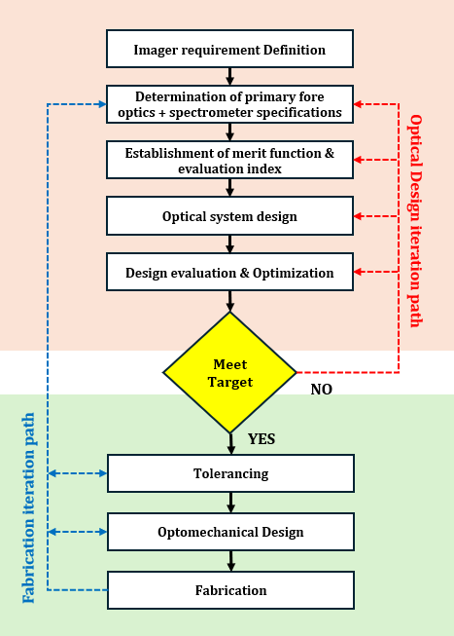
Initial design and performance requirements were set, and the optical system is drafted based on these first-order specifications. Achieving an optimal design often requires multiple iterations, given the intricate relationships among various performance metrics [24]. In cases where balancing these metrics proves challenging, it may be necessary to refine the design through numerous iterations. As a final resort, one or more design requirements may need to be relaxed to prioritize meeting another, more critical requirement. This iterative process ensures that the final design strikes the best possible balance among competing objectives while fulfilling the most essential performance criteria. In the case of the proposed imager, SNR, MTF, GSD, were considered crucial design requirements while following the design iteration process as showing in fig. 2.1.

Figure 2.1 Flowchart of the design iteration process in engineering

3.1 Working Principle
The structure of the hyperspectral imager is depicted in figure 2.2 below. The light collected from the fore optics passes though the slit and is collimated at $(L_{1})$ before hitting with transmission grating (G) and considering energy efficiency as a top priority, low groove densities of 300 grooves/mm were chosen. The transmission grating separates the spectrum and focuses the different spectrum on the CMOS sensor (C).
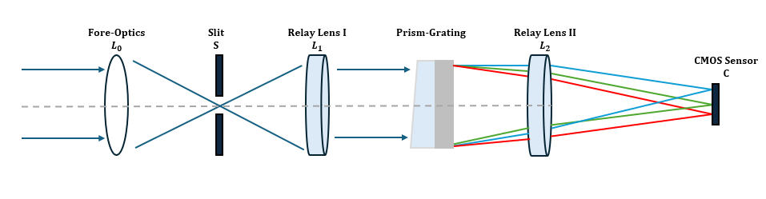
Figure 2.2 Chosen Spectrometer Schematic

3.2 Optical Design
3.2.1 Fore Optics Design
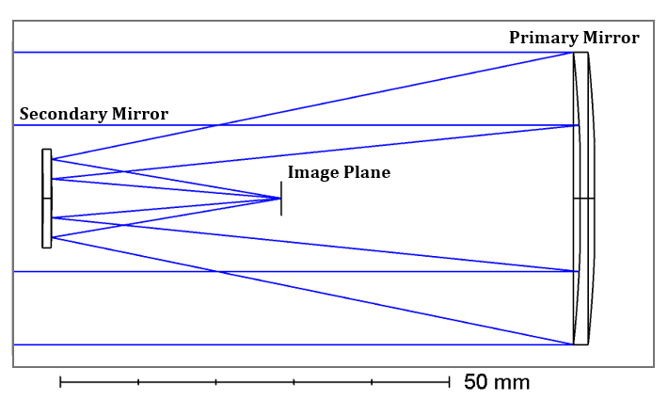
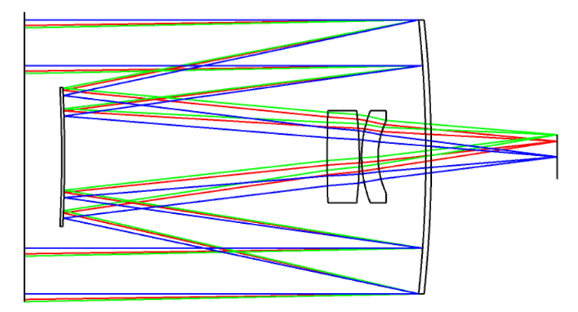
The fore optics is a simple catadioptric Cassegrain telescope which utilizes two distinct mirrors: one concave and one convex. Positioned at the base of the telescope tube, the primary mirror is parabolic in shape with a central opening. Meanwhile, the secondary mirror, which is hyperbolic and convex, is smaller in size and placed near the top of the tube, within the focal point of the primary mirror [25]. But as illustrated in Fig. 3.1a, the image plane of a Cassegrain telescope typically lies behind the primary reflector, facilitating the installation of sensors or eyepieces. However, in this payload system, re-imaging is necessary to incorporate hyperspectral imaging capabilities (spectrometer), and there is a constraint on system overall length. Therefore, as depicted in Fig. 3.1b, the image plane is repositioned inside the telescope, specifically between the primary and secondary reflectors. This arrangement allows the collimator to be placed internally, further reducing the overall system length.
(b) Internal image plane
(a) External image plane
Fig.3.1 Cassegrain telescope layout

However, this alteration introduces some drawbacks. Specifically, the available space between the image plane and the secondary reflector is decreased, preventing the insertion of correction lens. Consequently, the system cannot achieve diffraction-limited image quality, and any residual aberrations must instead be compensated for by the collimator lens assembly.
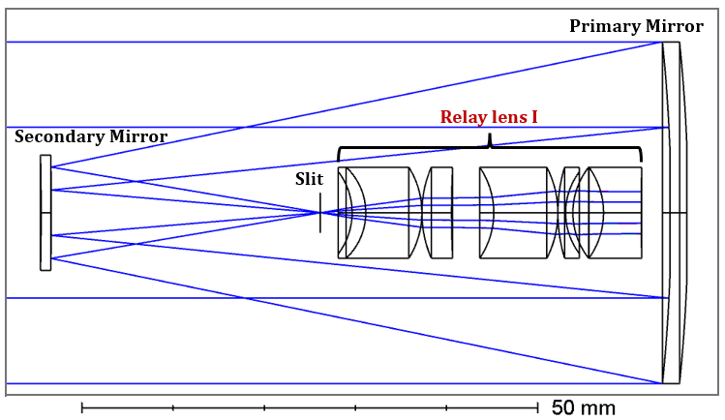
The role of the collimator lens group is to transform the image formed by the fore-optics into parallel rays before directing them onto the grating. In this paper, the collimator lens group additionally corrects residual aberrations originating from the fore-optics.
An appropriate initial lens structure is chosen based on experience, and an idealized lens replaces the condenser in the initial layout. The optimized arrangement of the lens group is illustrated in Fig. 3.2

Fig.3.2 Collimator lens group layout

3.2.2 Spectrometer Design
The fore-optics consist of a reflective telescope, which exhibits polarization sensitivity. To prevent exacerbating this sensitivity, a transmission diffraction grating is employed. Since maximizing energy efficiency is critical, a diffraction grating with a low groove density of 300 grooves/mm is selected. The spectrometer design consists of a planar-type transmission grating element and a condenser lens group. The condenser lens group's purpose is to refocus the dispersed spectra onto the image sensor. During optimization, particular attention should be given to the angles at which different fields of view (FOV) strike the sensor. Ideally, the rays should arrive as perpendicular as possible, meaning the lens group should be designed to be telecentric. The layout of the spectrometer can be seen in Fig 3.3 below

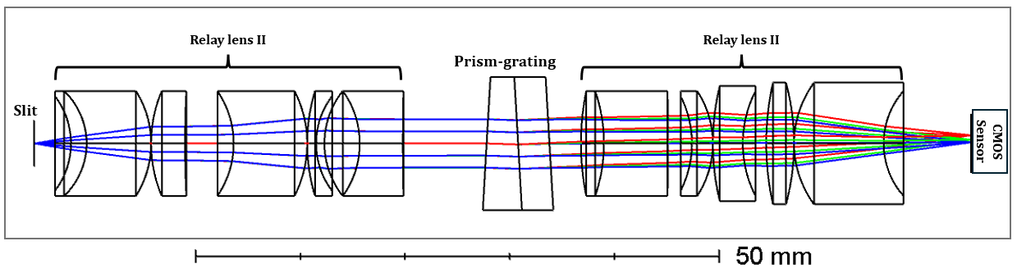
Fig.3.3 Condenser lens group layout

3.2.3 System matching
Ensuring a seamless integration between the fore optics and spectrometer entails aligning the output rays of the former with the input rays of the latter at their connection plane. Ideally, this alignment would occur without compromising the individual image quality of each system. However, achieving this ideal scenario is impractical. Instead, in practice, certain first-order quantities are matched as an approximation of perfect alignment. There are several types of system matching that were considered some of which are F-number match at an internal image, pupil match in the space of collimation, perfect match for every ray, and F-number and chief ray match in a general internal image[26].
In this optical system, the connection plane is located at an internal image plane of the entire system and is telecentric in both systems, matching the F-number or numerical aperture can establish a first-order match, as depicted in Figure 3.4
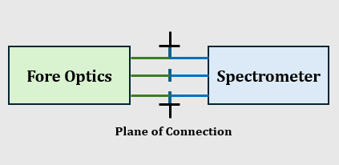

Fig.3.4 Pupil match in the space of collimation schematic

3.2.4 Combined System
After aligning the two subsystems, joint optimization was performed using Zemax. The three optical lens groups were integrated and re-optimized to establish the final optical configuration, as illustrated in Fig. 3.5. Among the optical components, only the primary reflector is parabolic, while the remaining lenses are spherical. The overall length from the secondary reflector to the sensor is kept below 115 mm. The system achieves a modulation transfer function (MTF) greater than 0.4 at the Nyquist frequency of 86.2 lp/mm. The maximum distortion is 1.04%, appearing at the marginal field of view (FOV). Additionally, the largest angle of incidence at the image plane is 0.8 degrees, also occurring at the marginal FOV.
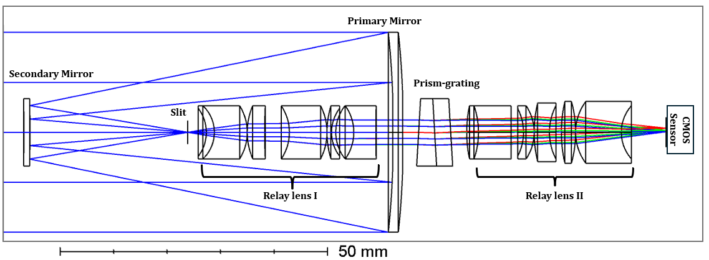
Fig. 3.5 Final System layout

The collimator and condenser lens groups constitute a 4-f optical system. To avoid any resolution loss, their focal lengths must be identical, resulting in a total length of four times the chosen focal length. A focal length of 20 mm was selected, making the distance from the slit to the sensor 80 mm. Including the telescope, the complete system length complies with the 150 mm design constraint. Additionally, to prevent energy loss, the F-number (F/#) of the lens groups should not exceed that of the telescope; thus, an F/# of 4 was adopted.

3.3 Optomechanical Design
3.3.1 Mechanical Design overview
The optomechanical design of the hyperspectral imager was conducted after meeting all targets as shown in Fig xx of section XX. Considering the initial design requirements, all materials and components were applied or designed to ensure space environment worthiness and compactness. In the case of this hyperspectral imager, the main mechanical constraint is the limited space allowance in CubeSat. The goal was to design a complete mechanical structure within 1.5U in a 3U CubeSat. Because a CubeSat must accommodate avionics electronics and fundamental structural components, the available volume for the hyperspectral imager is constrained. In the proposed configuration, however, an optimization of the optical elements yielded a 118 mm total track imager which resulted in the use of only about 120 mm × 100 mm × 100 mm of the total Cubesat volume. Figure XXX shows an overview of the ruggedized hyperspectral imager in a 1.2U box.
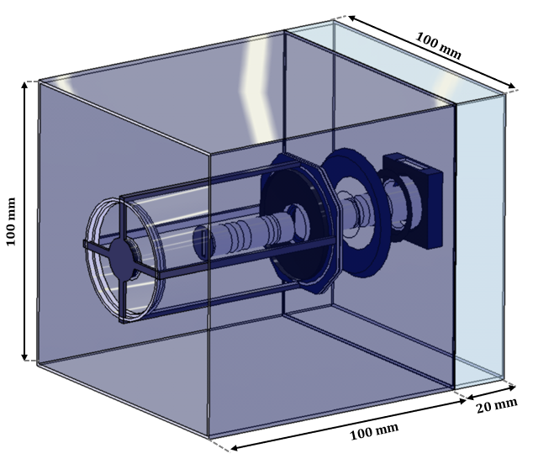

100 mm × 100 mm × 100 mm was then allocated for avionics, while additional structural elements were allocated a volume of 50 mm × 100 mm × 100 mm. Accordingly, the optical system was designed to fit within the initial design requirement, as illustrated in Fig. 2
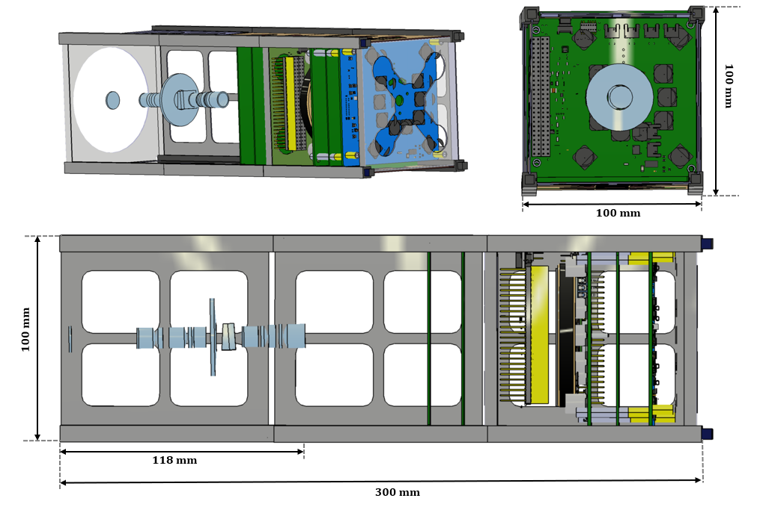

3.3.2 Component assembly
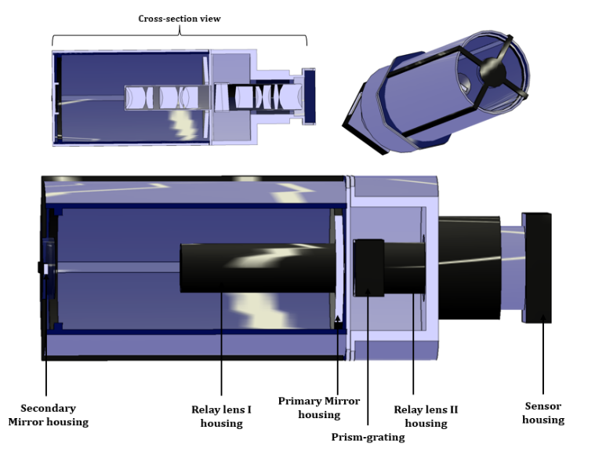
After fabricating the hyperspectral imager, a prototyping experiment using an optical bench was intended to verify and compare the performance with pre-fabrication simulation results. Therefore, the lens and mirror elements were grouped into different modules instead of one integrated assembly. This was to make it easier to mount on an optical bench and most importantly enable optomechanical iterations if the prototype doesn’t meet the required performance.

Relay lens I will be assembled into an individual housing while relay lens II and the prism-grating will be assembled into one housing connection. This modular housing configuration enables independent qualification testing of the relay lenses following fabrication [27]. The primary and secondary mirrors will each have their individual housing to be individually mounted on the optical bench. Figure xxx shows the complete and cross-sectional view of the hyperspectral imager.
3.3.3 Integrating into CubeSat
The hyperspectral imager after the optomechanical design was completed occupied a total of about 120 x 100 x 100 of the total 3U form factor meeting the size constraint of 1.5U. The finalized integrated imager is shown in figure XX
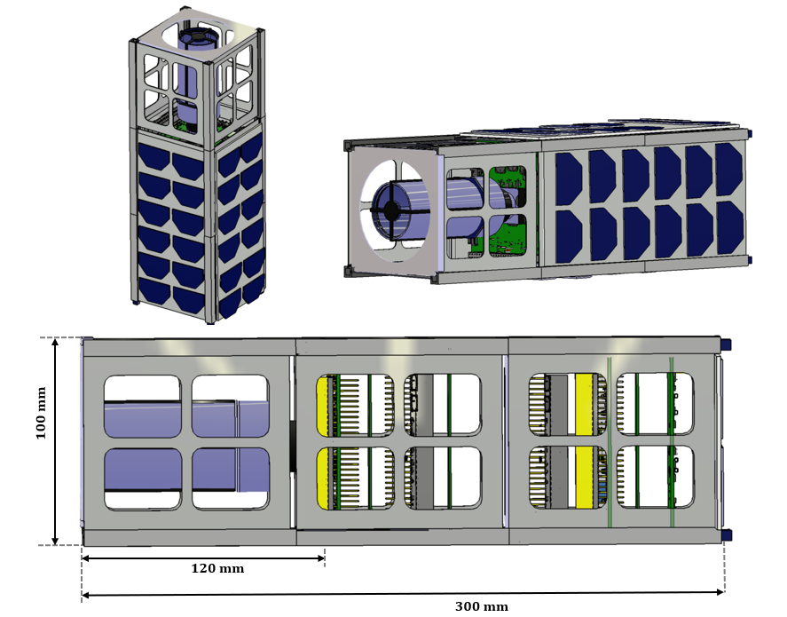

Result Analysis
4.1
4.1.1
4.2

[1] D. Selva and D. Krejci, “A survey and assessment of the capabilities of Cubesats for Earth observation,” May 2012. doi: 10.1016/j.actaastro.2011.12.014.
[2] P. Chadalavada and A. Dutta, “Regional CubeSat Constellation Design to Monitor Hurricanes,” IEEE Transactions on Geoscience and Remote Sensing, vol. 60, 2022, doi: 10.1109/TGRS.2021.3124473.
[3] J. N. Pelton and S. Madry, Handbook of Small Satellites: Technology, Design, Manufacture, Applications, Economics and Regulation: With 476 Figures and 92 Tables. Springer International Publishing, 2020. doi: 10.1007/978-3-030-36308-6.
[4] D. Gadisa and H. Bang, “Small Satellite Electro-Optical System (EOS) Technological and Commercial Expansion,” Dec. 01, 2023, Elsevier Ltd. doi: 10.1016/j.actaastro.2023.09.010.
[5] R. Sandau, “Status and trends of small satellite missions for Earth observation,” Jan. 2010. doi: 10.1016/j.actaastro.2009.06.008.
[6] M. Swartwout, “Cubesat census.” Accessed: Dec. 03, 2025. [Online]. Available: https://sites.google. com/a/slu.edu/swartwout/cubesat-database/census?authuser=0.
[7] P. Mouroulis et al., “Trade Studies in Multi/hyperspectral Imaging Systems Final Report.”
[8] S. E. Qian, “Hyperspectral Satellites, Evolution, and Development History,” 2021, Institute of Electrical and Electronics Engineers Inc. doi: 10.1109/JSTARS.2021.3090256.
[9] Y. Liu, A. Bauer, T. Viard, and J. P. Rolland, “Freeform hyperspectral imager design in a CubeSat format,” Opt. Express, vol. 29, no. 22, p. 35915, Oct. 2021, doi: 10.1364/oe.439530.
[10] J. H. Lee, T. S. Jang, H. S. Yang, and S. W. Rhee, “Optical design of a compact imaging spectrometer for STSAT3,” J. Opt. Soc. Korea, vol. 12, no. 4, pp. 262–268, 2008, doi: 10.3807/JOSK.2008.12.4.262.
[11] C. Graham, J. M. Girkin, and C. Bourgenot, “Freeform based hYperspectral imager for MOisture Sensing (FYMOS),” 2021.
[12] H. Jin, J. Lim, Y. Kim, and S. Kim, “Optical Design of a Reflecting Telescope for CubeSat,” J. Opt. Soc. Korea, vol. 17, no. 6, pp. 533–537, Dec. 2013, doi: 10.3807/josk.2013.17.6.533.
[13] P. Mouroulis, B. Van Gorp, R. O. Green, and D. W. Wilson, “Optical design of a CubeSat-compatible imaging spectrometer,” in Imaging Spectrometry XIX, SPIE, Sep. 2014, p. 92220D. doi: 10.1117/12.2062680.
[14] M. Esposito and A. Zuccaro Marchi, “In-orbit demonstration of the first hyperspectral imager for nanosatellites,” SPIE-Intl Soc Optical Eng, Jul. 2019, p. 71. doi: 10.1117/12.2535991.
[15] K. K. Awais Ahmed, “Pixxel hyperspectral imaging constellation.” Accessed: Dec. 29, 2025. [Online]. Available: https://www.pixxel.space/hyperspectral-imagery.
[16] M. Esposito, S. S. Conticello, M. Pastena, and B. Carnicero Dominguez, “In-orbit demonstration of artificial intelligence applied to hyperspectral and thermal sensing from space,” SPIE-Intl Soc Optical Eng, Aug. 2019, p. 11. doi: 10.1117/12.2532262.
[17] Y. Aoyanagi, “On-orbit demonstration of a linear variable band-pass filter-based miniaturized hyperspectral camera for CubeSats,” J. Appl. Remote Sens., vol. 18, no. 04, Oct. 2024, doi: 10.1117/1.jrs.18.044512.
[18] X. Zhang et al., “Design of a Prism-Grating Wide Spectral Range Transmittance Imaging Spectrometer,” Sensors, vol. 23, no. 11, Jun. 2023, doi: 10.3390/s23115050.
[19] Q. Xue et al., “Underwater hyperspectral imaging system using a prism–grating–prism structure,” Appl. Opt., vol. 60, no. 4, p. 894, Feb. 2021, doi: 10.1364/ao.415351.
[20] C. Song, K. Yuan, and W. Zhou, “Design of an High-Speed Near-Infrared Hyperspectral Camera Using Prism-Grating Dispersion,” in 2025 23rd International Conference on Optical Communications and Networks, ICOCN 2025, Institute of Electrical and Electronics Engineers Inc., 2025. doi: 10.1109/ICOCN67308.2025.11145739.
[21] H. Jin, J. Lim, Y. Kim, and S. Kim, “Optical Design of a Reflecting Telescope for CubeSat,” J. Opt. Soc. Korea, vol. 17, no. 6, pp. 533–537, Dec. 2013, doi: 10.3807/josk.2013.17.6.533.
[22] A. Näsilä et al., “The Asteroid Spectral Imager (ASPECT) on the Milani CubeSat,” Space Sci. Rev., vol. 221, no. 7, Oct. 2025, doi: 10.1007/s11214-025-01193-3.
[23] S. Maurice et al., “The SuperCam Instrument Suite on the Mars 2020 Rover: Science Objectives and Mast-Unit Description,” Apr. 01, 2021, Springer Science and Business Media B.V. doi: 10.1007/s11214-021-00807-w.
[24] C. Joseph Middleton, “A Holistically Designed Hyperspectral Imager For CubeSats,” 2022.
[25] Ö. Karci, “A simulation and experimental validation of third-order coma in nodal aberrationtheory with a Cassegrain telescope,” Turkish Journal of Physics, vol. 45, no. 6, pp. 378–389, 2021, doi: 10.55730/1300-0101.1002.
[26] C. Joseph Middleton, “A Holistically Designed Hyperspectral Imager For CubeSats,” 2022.
[27] I. Shofman, M. G. Neto, T. Ganesh, K. He, A. Armstrong, and K. Narkevich, “SSC25-P1-22 FINCH EYE: The Optical and Optomechanical Design of a GRISM-based SWIR Hyperspectral Imaging Payload for a 3U CubeSat.”

